Test Plan for OrangeHRM website
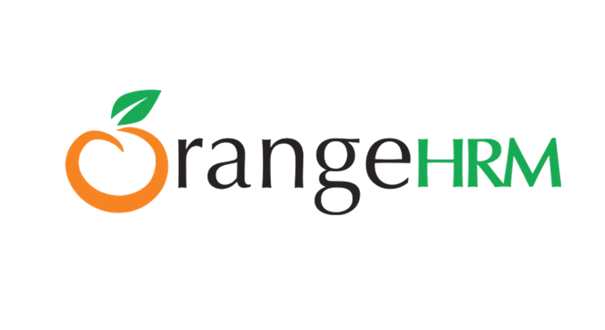
OrangeHRM

Master Test Plan

Document Version: 001
Date: 22 June 2025

Created By :
Mai Okasha
Saif Araj
Zaid Jaber
Lina Shaqoura

TABLE OF CONTENTS :

- Introduction ………………………………………………………………………………… 2
- Objectives ………………………………………………………………………………… 2
- Test Approach …………………………………………………………………………… 2
- Scope ……………………………………………………………………………………………. 3
4.1 Features in Scope …………………………………………………………….. 3
4.2 Features out of Scope …………………………………………………… 3
- Test Deliverables …………………………………………………………………….. 5
5.1 Before Testing ……………………………………………………………………… 5
5.2 During Testing ………………………………………………………………….…. 5
5.3 After Testing …………………………………………………………………….…. 5
- Schedule ……………………………………………………………………………….…… 6
- Roles & Responsibilities ……………………………………………………..… 7
- Entry & Exit Criteria ……………………………………………………………..… 8
8.1 Entry Criteria ……………………………………………………………………..… 8
8.2 Exit Criteria ………………………………………………………………………... 8
- Resources & Environment Needs ……………………………………. 8
9.1 Testing Tools …………………………………………………………………….…… 8
9.2 Test Environments …………………………………………………………..…. 8
- Risk Management ……………………………………………………………..…… 9
- Approval ……………………………………………………………………………..… 9

- Introduction

This document provides the overall testing strategy and approach required to ensure that the requirements of the OrangeHRM are tested adequately and that the required levels of quality and reliability of the software deliverables are attained.

- Objectives
The goal of this test plan is to identify and eliminate defects in
The OrangeHRM system before released to ensure a stable and
user-friendly application. This will be achieved by validating
that all functional and user interface requirements are met
defined specifications.

- Test Approach
The project is based on functional testing, including Exploratory, u Smoke, and Sanity testing.
All tests will be performed manually with daily iterations as per u cycles at the end of each day. The specific requirements for u u those iterations will be delivered to the team and tested.

- Scope

4.1 In Scope

- My Info Module ( EES View )
· Photograph
· Contact Details
· Emergency Contact
· Dependents
· Immigration
· Job
· Salary
· Report To
· Qualifications
· Membership

- Admin Module
· User Management Module
· Job Module
- Job Titles
- Pay Grades
- Employment Status
- Job Categories
- Work Shifts
· Organization Module
· General Details
· Locations
· Structure

· Qualifications Module
- Skills
- Education
- License
- Languages
- Memberships

4.2 Out of Scope
- HR Admin Account
- Localization
- API Testing
- Backup Testing
- Performance Testing

- Test Deliverables

5.1 Before Testing

Test Cases, RTM, and Test Plan.

5.2 During Testing

Test Cases, Test Data & Bug Reports.

5.3 After Testing

Test Summary Report.

- Schedule
1.1 Employee
Task | Duration | Start Date | End Date
User Management Module | 2 Days | 22 Jun 2025 | 24 Jun 2025

1.2 HR Admin
Task | Duration | Start Date | End Date
User Management Module | 2 Days | 22 Jun 2025 | 24 Jun 2025
Job Module | 2 Days | 22 Jun 2025 | 24 Jun 2025
Organization Module | 2 Days | 22 Jun 2025 | 24 Jun 2025
Qualification Module | 2 Days | 22 Jun 2025 | 24 Jun 2025

- Roles & Responsibilities

Staff Member | Role | Responsibilities
Mamoun Suboh | Project Manager | - Assign tasks to team members.  - Review test activities & give feedback.  - Define project scope.
Afnan Kharof | QA Lead | - Provide continuous guidance to team members' progress.  - Conducting daily scrum meetings.  - Address team queries & clarify any ambiguities.
Mai Okasha | QA Engineer | Prepare test plan, test coverage, execute test cases, create Bug Report & Bug Summary Report.
Saif Araj | QA Engineer
Zaid Jaber | QA Engineer
Lina Shaqoura | QA Engineer

- Entry & Exit Criteria

8.1 Entry Criteria
- All features completed and deployed
- Test data available
- No blocking defects in the system
- Test environment accessible

8.2 Exit Criteria
- All critical test cases pass
- No major defects remain open
- Test summary approved
- All risks solved

- Resources & Environment Needs

9.1 Testing Tools

Tracking tool: Trello
Bug tracking: Microsoft Word & Excel.

9.2 Environment Test

Platform: Web
Os: Windows 11, MacOS
Browsers: Chrome & Microsoft Edge

- Risk Management

Risk
Requirements not clearly defined
Delays in test environment setup
Incomplete test coverage due to time constraints

- Approval

Name | Role | Approval Status | Date
Mai Okasha | QA Engineer | Approved | 22 Jun 2025
Saif Araj | QA Engineer | Approved | 22 Jun 2025
Zaid Jaber | QA Engineer | Approved | 22 Jun 2025
Lina Shaqoura | QA Engineer | Approved | 22 Jun 2025

